Digital Main Street: Futureproofing  
_________________________________________________  
  
Website analysis

Website Analysis Report for

*The Empathy Coach*



## **CURRENT WEBSITE**

*Url:* [*https://www.couplescommunication.ca/*](https://www.couplescommunication.ca/)

**Strengths**

* Professional overall UI/UX design
* Easy website navigation
* Headers and keywords used
* Secured website (A from SSL Labs)
* Attractive personal story

**Suggestions**

* **Change to a “.com” domain**

Since online consultation is offered, it is advised to expand the current business to a global context, especially the US. Based on GoDaddy search, domain names like “www.theempathycoach.com” and “www.empathycoach.com” are no longer available. We suggest using “www.empathy-coach.com” or “www.couples-communication.com” or similar. Below is the search result from GoDaddy.

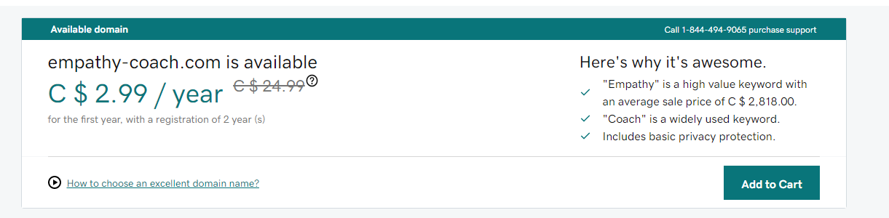

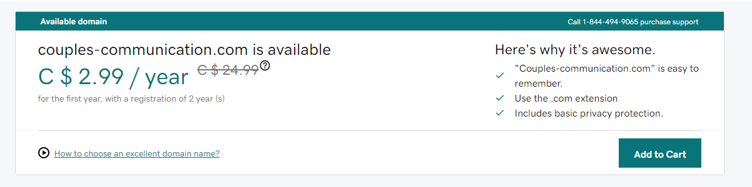

* **Improve Google search presence**

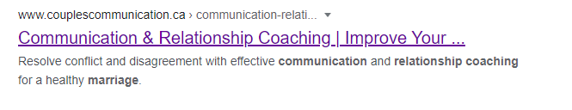

The title is omitted by google, so it is suggested to change the title to “Communication Coaching | Improve Marriage” or “Communication Coaching | Improve Relationship” to gain better presence.

* **Add a brand logo**

It is suggested to add a logo into the following two areas to increase the credibility and formality of the business.

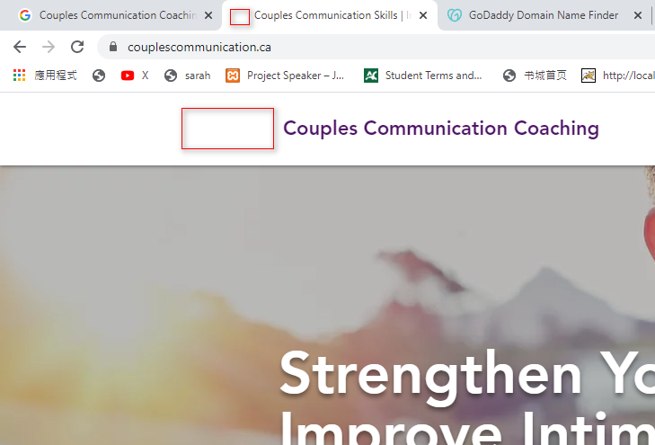

* **Add social media links**

Adding social media links helps grow your followers. Meanwhile, it builds trust and demonstrates authenticity. Customers today are no longer only looking for a well-polished brand and story that say all the good things. Instead, they want to dig deeply into the business, and by redirecting your site visitors to your social media pages, you can show them who you truly are in an authentic, meaningful, and transparent way. Wix should have its existing UI component for social website icons and links which can be easily incorporated into the current website.

* **Redesign the footer**

The current footer only contains email and phone. A better footer would also increase the credibility and formality of the website, and it also helps SEO by including links to your main personal website or other public resources related to couple communication & relationship. Please consider adding elements like company name, logo, selling points of the service, links to your information or social media, copyright notice and call-to-action.

* **Highlight the Calendly UI**

In the Contact page, the current “booking” area looks like google promotion advertisement, and it took me some time to finally figure out this area is used for booking consultation.

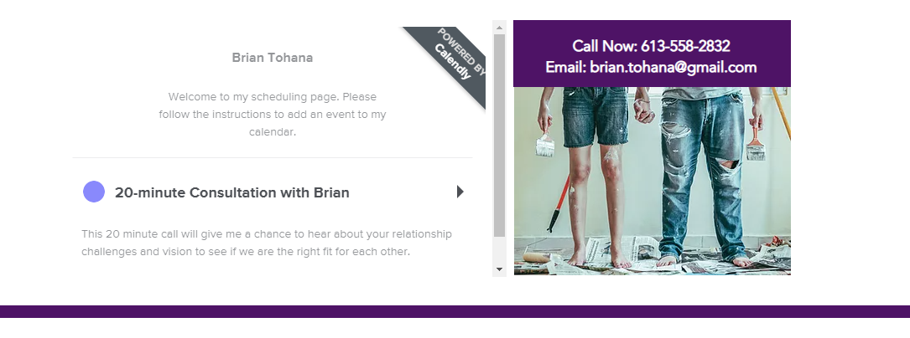

Below is an example which also uses Calendly for your reference. Also, you can relocate “my story” to the home page.

<https://calendly.com/skincareconsultation/book?month=2020-11>

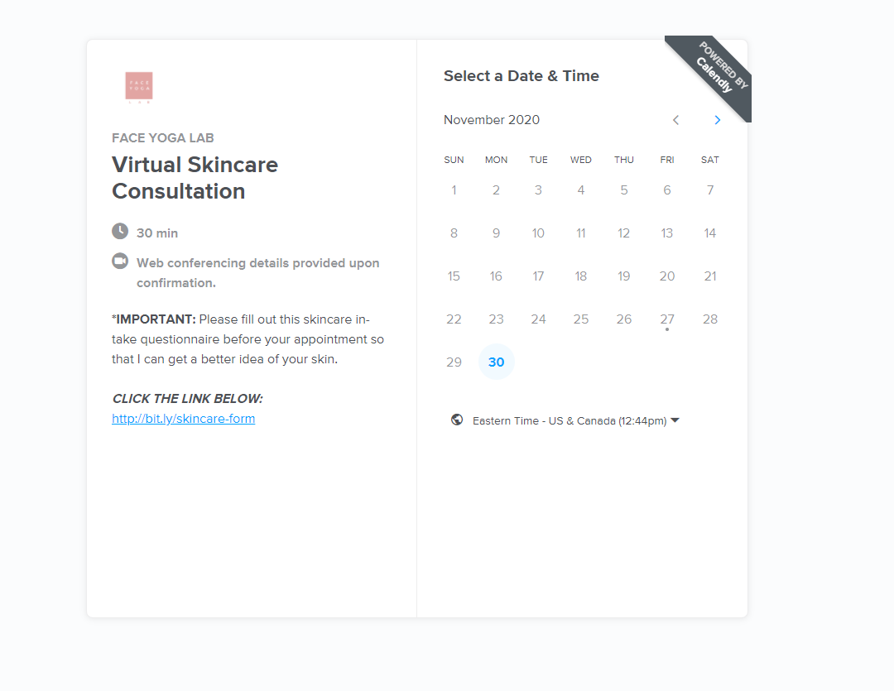

* **More content in Blog page**

It is better to have at least three articles or even more on the blog page.

* **Security**

The website gains “A“ from the SSL Labs test, and this is good enough.

